Supplement 1: Appendixes A-D

Appendix A

E. coli Cell-Free Lysate Protocol (Adapted from Krinsky et al., 2016)

Developed by Owen Koucky, Davidson College Biology Dept.

Glassware and Instruments:
- two 100 mL Pyrex bottles–sterilize by autoclaving
- two 2 L Erlenmeyer flasks–sterilize by autoclaving
- four 250 mL centrifuge bottles–sterilize by autoclaving
- two 50 mL conical tubes–sterilize by autoclaving (unless they come pre-sterilized)
- Beckman Coulter Avanti J-E centrifuge
- Beckman JA-14 rotor–pre-chilled at 4 ºC
- Beckman JA-25.50 rotor–pre-chilled at 4 ºC
- AVESTIN EmulsiFlex B-15 High Pressure Homogenizer–pre-chilled at 4 ºC overnight before use
- House air ≥ 60 psi
- two 15 to 30 mL Luer-Lok Tip syringes–pre-chilled at 4 ºC (they come pre-sterilized)
- one 100 mL stainless steel beaker–pre-chilled at 4 ºC
- two 30 mL Corex centrifugation tubes with adapters–sterilize by autoclaving, pre-chilled at 4 ºC
- about seventy-five 1.5 mL Eppendorf tubes–pre-chilled at 4 ºC

TO BE DONE (AT LEAST) ONE DAY BEFORE STARTING LYSATE PREP:

Preparation of solutions:

1 M Tris-Acetate, pH 7.4 (100X)
To make 500 mL: dissolve 60.57 g Tris (Mallinckrodt #7732-05, FW 121.14 g/mol) in 300 mL dH₂O. Adjust pH to 7.4 with glacial acetic acid. Bring to volume with additional dH₂O. Store at room temperature.

1 M Magnesium Acetate
To make 500 mL: dissolve 107.23 g Mg(OAc)₂ (Fisher #BP215-500, FW 214.26 g/mol) in 300 mL dH₂O. Bring to volume with additional dH₂O. Store at room temperature.

1 M Potassium Acetate
To make 500 mL: dissolve 49.07 g K(OAc) (Fisher #BP364-500, FW 98.14 g/mol) in 300 mL dH₂O. Bring to volume with additional dH₂O. Store at room temperature.

100 mM Dithiothreitol (DTT)
To make 25 mL: dissolve 0.386 g DTT (Sigma-Aldrich #D0632, FW 154.25 g/mol) in 20 mL dH₂O. Bring to volume with additional dH₂O. Sterilize by one pass through a 0.22 µm syringe filter. Store frozen at -20 ºC.

100 mM Isopropyl β-D-1-thiogalactopyranoside (IPTG)
To make 5 mL: dissolve 0.119 g IPTG (Zymo Research #ZRC159855, FW 238.31 g/mol) in 3 mL dH₂O. Bring to volume with additional dH₂O. Sterilize by one pass through a 0.22 µm syringe filter. Store frozen at -20 ºC. Avoid freeze-thawing IPTG. If frozen 100 mM IPTG aliquots are in the freezer, thaw the requisite number of aliquots on the day of big culture growth and then filter sterilize 5 mL before adding the sterile IPTG to the big cultures.

S30 Lysis Buffer
Contains:
- 10 mM Tris-acetate, pH 7.4;
- 14 mM Mg(OAc)₂;
- 60 mM KOAc;
- 1 mM DTT;
- 0.5 mL/L 2-mercaptoethanol (Sigma #M-6250, FW 78.13 g/mol)

To make 1 L, combine 10 mL 1 M Tris-acetate, pH 7.4; 14 mL 1 M magnesium acetate; and 60 mL 1 M potassium acetate. Bring to volume with dH₂O. Aliquot into two 1 L bottles with lids. Autoclave. Store at 4 ºC.

Sterilize a small amount of 2-mercaptoethanol by one pass through a 0.22 µm syringe filter. Be warned: 2-mercaptoethanol is notorious for its stench and it is toxic upon skin exposure. Wear gloves while sterilizing the 2-mercaptoethanol under a hood. Store at -20 ºC.

Before use of the S30 lysis buffer on lysate prep day, add 250 µL sterile 2-mercaptoethanol and 5 mL sterile 100mM DTT to each 500 mL aliquot. Keep S30 lysis buffer cold (4 ºC) throughout use.

TB (terrific broth) Media
Per Molecular Cloning (Sambrook and Russell, 2001):

Make two, 500 mL aliquots by adding 6 g tryptone, 12 g yeast extract, and 2 mL glycerol to 450 mL dH₂O (water first then add solutes) in two, 2 L Erlenmeyer flasks. Shake until solutes have dissolved. Set the broth mixtures aside.

Next, prepare 100 mL of a solution of 0.17 M KH₂PO₄, 0.72 M K₂HPO₄. Dissolve 2.31 g KH₂PO₄, and 12.54 g K₂HPO₄ in 90 mL dH₂O. After the salts have dissolved, bring to volume with additional dH₂O. Split the salt solution into two, 50 mL aliquots in 100 mL Pyrex bottles.

After the broth and salt solutions are made, autoclave them. Following sterilization, allow the broth to cool to 60 ºC or less then add 50 mL of the salt solution to each 500 mL broth aliquot while maintaining sterility. Store at room temperature.

DAY ZERO (the night before lysate prep day):

Overnight Culture:
At 5:00 pm the day before the lysate prep, establish two 10 mL cultures of NEB T7 Express BL21 (DE3) or BL21* cells in LB media with no antibiotics in sterilized 100 mL Pyrex bottles with caps slightly loose but taped on so they don’t wiggle off. Be sure to maintain sterility. Incubate cultures overnight in the floor incubator shaker at 37 ºC with shaking at 250 rpm.

LYSATE PREP DAY:

Day of Big Culture Growth:
At 8:00 am on lysate prep day, use the two 10 mL starter cultures to inoculate 500 mL TB media in two 2 L Erlenmeyer flasks. Add 2 mL 100 mM IPTG to each flask for a final concentration of 0.4 mM IPTG. IPTG addition induces T7 RNA polymerase synthesis. Incubate these cultures at
37 ºC with shaking at 250 rpm in the benchtop incubator shaker. Monitor the optical density (OD) of the cultures at 600 nm by sterilely collecting 200 µL samples from the growing cultures and reading them for optical density. Don’t forget to correct for background light absorbance by the TB media.

Continue monitoring the optical density of the cultures and plot the OD₆₀₀ values against time since inoculation. Don’t forget to correct for background light absorbance by the TB media by measuring the OD₆₀₀ of a well filled with plain TB media. Krinsky et al. indicate that the daytime culture should grow until OD₆₀₀ ≈ 4, but we have not achieved OD₆₀₀ >1.4, and instead see optical density reaching a plateau close to OD₆₀₀ ≈ 1.3 between 8- and 9-hours post-inoculation. Halt culture incubation upon observation of a plateau in OD₆₀₀.

Centrifugation I + II:
Load cultures into four sterile 250 mL centrifuge bottles, omitting any culture necessary to avoid overfilling the bottles. Ensure each bottle is within 0.1 g in mass of each other. Centrifuge at 7,000 rpm (7,520 x g) for 10 minutes at 4 ºC using a Beckman JA-14 rotor. This is centrifugation I.

Following centrifugation I, decant supernatant from each centrifuge bottle and resuspend each pellet in 250 mL cold S30 lysis buffer (4 ºC). Resuspend the pellets by shaking them in ~30 mL S30 lysis buffer and bring the resuspension to volume with S30 lysis buffer once the pellet is fully resuspended. Ensure each bottle is within 0.1 g in mass of each other. Centrifuge at 7,000 rpm (7,520 x g) for 10 minutes at 4 ºC using a Beckman JA-14 rotor. This is centrifugation II.

Following centrifugation II, decant supernatant from each centrifuge bottle and resuspend each pellet in 3.75 mL cold S30 lysis buffer (4 ºC). Resuspend the pellets by shaking. Combine the four resuspended pellets in a 50 mL sterile conical tube. Keep the resuspension on ice. When combined, the total volume of the resuspended cells should be ~15 mL.

Homogenization:
Load the resuspension into a pre-chilled (4 ºC) 15 to 30 mL sterile syringe. Prepare to use the AVESTIN EmiulsiFlex B-15 high-pressure homogenizer (Supplementary Figure 1). The homogenizer can only process samples between 3 and 15 mL, so any resuspension in excess of 15 mL will have to be homogenized in multiple aliquots. The homogenizer is stored in a cold room and is very heavy, so bring a cart to transfer the homogenizer from the cold room.
Movie of method: https://youtu.be/pQxlm8MZQUQ
Movie of cleanup process: https://youtu.be/jROCREn5Qos

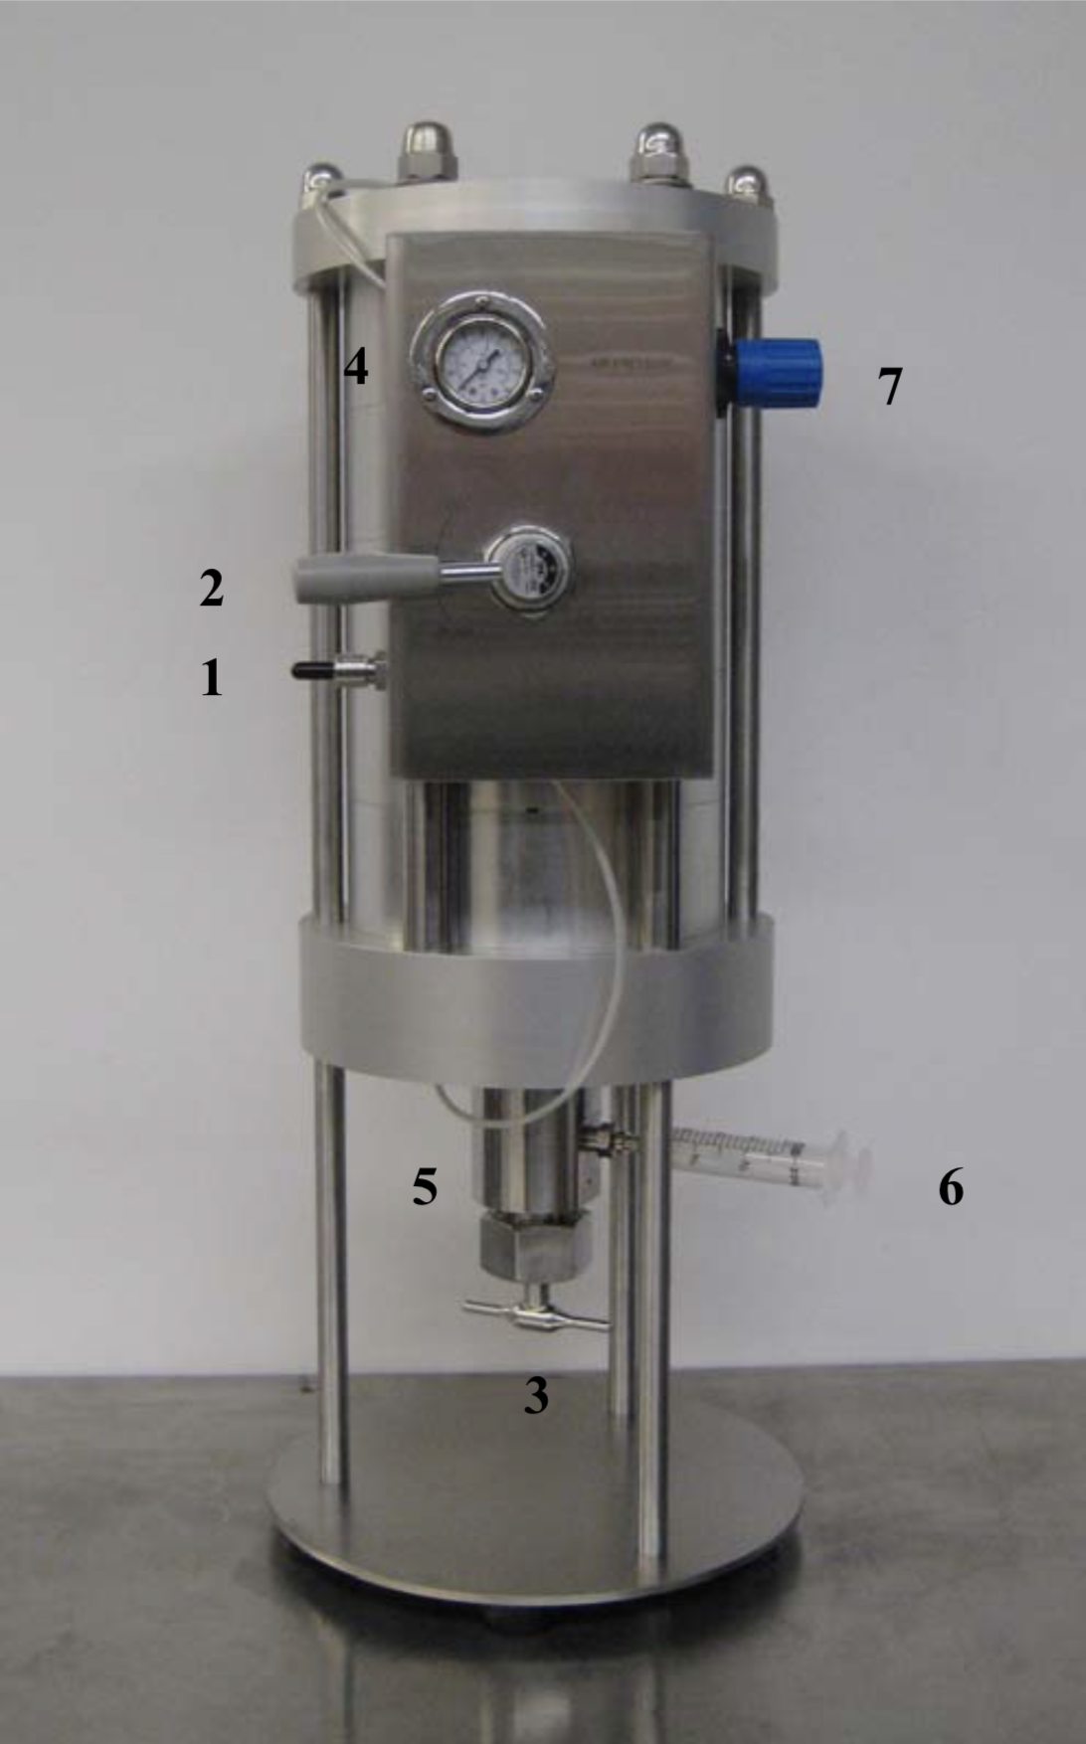

Supplementary Figure 1 AVESTIN EmulsiFlex B-15 high pressure homogenizer with labeled parts. The following parts can be identified by their numerical labels in the figure: (1) air intake nozzle, (2) air control knob, (3) homogenizing valve, handle (4), air pressure gauge (5), homogenizing valve, (6) inlet/outlet fitting and syringe, (7) air pressure regulator.

- First, prepare the homogenizer for use by ensuring it is on a flat, level surface and by attaching the luer-lock-threaded fitting included in the homogenizer kit to the inlet/inlet outlet fitting (6) using the provided wrench. Next, attach the blue tubing to the high-pressure air source by fitting the cut end to the air source and the quick-attachment fitting to the air intake nozzle (1) on the homogenizer. With the air control knob (2) in the “OFF” position, turn the air source on. You will notice an increase in pressure on the air pressure gauge (4). Adjust the air pressure to 50 psi as indicated on the air pressure gauge (4) using the air pressure regulator (7) for a homogenizing pressure of 15,000 psi (homogenizing pressure = 300 x air pressure).

- Next, ensure that the homogenizing valve (5) is in the open position. If it is not, open the valve by turning the homogenizing valve handle (3) in a clockwise fashion until turning the handle becomes noticeably easier. After opening the valve, move the air control knob (2) to the “PUMP” position. Once the air noise stops, attach the iced syringe containing the resuspension to the luer-lock-threaded fitting, which is mounted on the inlet/outlet fitting (6) of the homogenizer. Move the air control knob (2) to the “FILL” position and observe the sample being drawn into the homogenizer. As soon as the syringe is empty, move the air control knob (2) to the “OFF” position.

- Next, close the homogenizing valve (5) by turning the homogenizing valve handle (3) in a counter-clockwise fashion until finger-tightness. Once the valve is closed, move the air control knob (2) to the “PUMP” position. After this, slowly and steadily turn the homogenizing valve handle (3) in a clockwise fashion to open the valve (5) until resuspension becomes visible as it refills the syringe to its original volume. Allow the syringe to slowly fill with the now-lysed resuspension until it stops. At this point, continue slowly and steadily turning the homogenizing valve handle (3) to ensure even homogenization throughout until the homogenizing valve (5) is fully open (turning the valve handle will become easier once the valve is fully open; stop turning at this point). Remove the syringe after one pass of the resuspension through the homogenizer and quickly move to the next step.

- Once the sample has been homogenized, chill the sample by placing it into the provided (pre-chilled, 4 ºC) 100 mL stainless steel beaker on ice. While the sample is in the metal beaker, add 100 µL 100 mM DTT for each 10 mL lysate produced (150 µL for 15 mL homogenate).

- If there is more resuspension to be homogenized, load the remaining resuspension into another pre-chilled (4 ºC) 15 to 30 mL sterile syringe, attach the syringe to the luer-lock fitting, and return to step 2.

- To clean the homogenizer, keep the air control knob (2) in the “PUMP” position and keep the homogenization valve (5) open (the air control knob should already be in the “PUMP” position and the homogenization valve should already be open following homogenization). Attach a syringe filled with water to the luer-lock-threaded fitting, which is mounted on the inlet/outlet fitting (6) of the homogenizer. Move the air control knob (2) to the “FILL” position to draw the water into the homogenizer. Then, move the air control knob (2) to the “PUMP” position to flush the water back into the syringe. Continue pumping the water between the homogenizer and the syringe by moving the air control knob (2) back and forth between the “FILL” and “PUMP” positions several times, letting all water exit or refill the syringe between each movement of the air control knob (2). Change the water in the syringe and repeat the washing a total of 3 times with dH₂O.

- After three washes, empty the homogenizer of all air. First, move the air control knob (2) to the “PUMP” position. Attach a syringe filled with water to the luer-lock-threaded fitting, which is mounted on the inlet/outlet fitting (6) of the homogenizer. Move the air control knob (2) to the “FILL” position and observe the sample being drawn into the homogenizer. As soon as the syringe is empty, move the air control knob (2) to the “OFF” position. When the air noise stops, move the air control knob (2) to the “PUMP” position. The syringe will fill with a volume that is equal to the original volume, some of which may be air that was contained in the homogenizer chamber. There is now no air in the homogenizer. Move the air control knob (2) to the “OFF” position and return the homogenizer and all associated parts to the cold room. Return the cart used for transporting the homogenizer to its place of origin.

Centrifugation III:
Load the homogenized lysate into a 30 mL pre-chilled (4 ºC) sterile Corex centrifugation tube. Prepare an equally-weighted (within 0.1 g) Corex tube to balance the centrifuge load. Centrifuge at 13,000 rpm (20,400 x g) for 30 minutes at 4 ºC using a Beckman JA-25.50 rotor.
Following centrifugation III, immediately place the lysate on ice in the Corex tube. Decant the supernatant into a pre-chilled (4 ºC) 50 mL conical tube and place this tube on ice. This supernatant is the final cell lysate.

Storage:
Keep the lysate on ice and divide the lysate into 200 µL aliquots in pre-chilled (4 ºC) 1.5 mL microfuge tubes using the repipetter on the 2 setting with the 6 mL loading syringes (Appendix C, Supplementary Figure 10). Keep the lysate aliquots on ice while loading them into an appropriate, well-labeled container before storing them in a -80 ºC freezer. Lysates can be thawed only once.

APPENDIX B

Preparing Reagents for in vitro Cell-Free Protein Synthesis (Adapted from Krinsky et al., 2016)

Preparation of stock solutions:

1 M HEPES-KOH, pH 8.0
To make 25 mL: dissolve 7.360 g HEPES (Sigma #H-3375, FW 238.30 g/mol) in 15 mL dH₂O.

Separately, prepare a 10 mL of a 2 M KOH solution by dissolving 1.122 g KOH in 6 mL dH₂O. Bring to volume with additional dH₂O.

Adjust pH to 8.0 using the 2 M KOH solution. Bring to volume with additional dH₂O.

1 M Magnesium Acetate
To make 50 mL: dissolve 10.723 g Mg(OAc)₂ (Fisher #BP215, FW 214.26 g/mol) in 30mL dH₂O. Bring to volume with additional dH₂O.

Alternatively, reserve a portion of the 1 M magnesium acetate prepared during the E. coli lysate prep for use in the CFPS reaction mixtures.

1 M Potassium Acetate
To make 50 mL: dissolve 4.907 g K(OAc) (Fisher #BP364, FW 98.14 g/mol) in 30mL dH₂O. Bring to volume with additional dH₂O.

Alternatively, reserve a portion of the 1 M potassium acetate prepared during the E. coli lysate prep for use in the CFPS reaction mixtures.

1 M Ammonium Acetate
To make 10 mL: dissolve 4.008 g NH₄(OAc) (Fisher #BP326, FW 77.08 g/mol) in 6 mL dH₂O. Bring to volume with additional dH₂O.

50% (v/v) Polyethylene Glycol-6000 (PEG-6000)
To make 5 mL: dissolve 5.0 g PEG-6000 (Fluka #81255, FW 6000 g/mol) in 5 mL dH₂O.

0.5 M 3-Phosphoglycerate (3-PGA)
To make 7 mL: dissolve 0.805 g 3-PGA (Sigma #P8877, FW 230.02 g/mol) in 4 mL dH₂O. Bring to volume with additional dH₂O.

Nucleoside Triphosphates (NTPs): ATP, GTP, UTP
Purchase an Illustra 100 mM NTP Set in the 25 µmol scale (GE Healthcare #27-2025-01). Use these 100 mM solutions as NTP stock solutions.

20-Amino Acid Solution
The 20-amino acid solution was prepared by following a literature protocol (Caschera and Noireaux, 2015) as closely as allowed by the solubility of the amino acids. Amino acids were purchased as solids in a kit (Sigma #LAA21), but several of the amino acids in the kit were not used, including trans-4-hydroxy-l-proline, L-cysteine hydrochloride, L-cystine (crystalline), L-histidine hydrochloride, and L-lysine hydrochloride. The kit included L-proline (Sigma #P0380) in addition to trans-4-hydroxy-l-proline and L-proline was used instead. To replace the remaining unused amino acids, we purchased three additional amino acids (Supplementary Table 1).

Supplementary Table 1. Amino acids purchased to supplement the amino acid kit (Sigma #LAA21).
amino acid | molecular weight (g/mol) | Sigma code
L-cysteine | 121.16 | 30089
L-lysine | 146.19 | L5501
L-histidine | 155.15 | 53319

To prepare the amino acid mixture, we dissolved 0.3 g of each of the 20 amino acids except for L-arginine monohydrochloride in either the protocol-instructed volume of 5 M KOH or in a minimal amount of 5 M KOH exceeding this protocol-instructed volume which would allow the amino acids to go into solution. L-arginine monohydrochloride was dissolved in a protocol-instructed volume of nuclease-free water (Fisher #BP2484-50). The final volumes of the individual 5 M KOH or nuclease-free water amino acid solutions can be found in Table 2. After we prepared these individual amino acid solutions, we aliquoted the solutions into 50 µL aliquots and stored them at -20 ºC.

Using the individual amino acid solutions, we prepared the 20-amino acid solution by pipetting each of the 20 individual amino acid solutions into an appropriate volume of nuclease-free water which would bring the final volume of the solution to 4 mL following the addition of each of these 20 individual amino acid solutions. In our case, the appropriate combined volume of the 20 individual amino acid solutions was 415.2 µL, which differed from the protocol-intended volume of 381.6 µL because some of the individual amino acid solutions we prepared were more dilute than the protocol intended. As such, we pipetted each of the 20 individual amino acid solutions into 3.5848 mL nuclease-free water. While Caschera and Noireaux’s protocol instructs a pH adjustment step following the preparation of the 20-amino acid solution, we have observed the amino acids come out of solution when the pH is adjusted and have demonstrated greater functionality of the CFPS system when we omit the pH adjustment step. After we prepared the 20-amino acid solution, we aliquoted the solutions into 50 µL aliquots and stored them at -20 ºC.

Supplementary Table 2. Organization for preparing the 20-amino acid solution. The table is most useful when read left-to-right. 0.3 g of each amino acid was dissolved in 5 M KOH (*or nuclease-free water in the case of arginine) for a final volume found in the third column. The concentrations the amino acids in each of these individual amino acid solutions can be found in the fourth column. A volume of each of these individual amino acid solutions indicated in the fifth column is pipetted into a volume of nuclease-free water such that the total volume of the water and amino acids reaches 4 mL. The concentrations of each of the 20 amino acids in the mixture of 5 M KOH amino acid solutions to be pipetted into the nuclease-free water can be found in the sixth column. The concentrations of each of the 20 amino acids in the 4 mL amino acid solution can be found in the seventh column. This table comes from a spreadsheet which may be manipulated to reflect adjustments needed to account for variable amino acid solubility. This spreadsheet is available by request to macampbell@davidson.edu.

amino acid | molecular weight (g/mol) | final volume 5 M KOH solution in which 0.3 g amino acid dissolved (mL) |  | individual amino acid concentration in 5M KOH (mM) | volume to take from 5 M KOH solution to prepare mixture (µL) |  | concentration in 5 M KOH amino acid mixture (mM) | concentration in 4 mL amino acid mixture (mM)
alanine | 89.09 | 0.860 |  | 3916 | 14.23 |  | 146 | 13.93
arginine* | 210.67 | 0.615 |  | 2315 | 22.25 |  | 135 | 12.88
asparagine | 132.12 | 0.752 |  | 3019 | 16.93 |  | 134 | 12.78
aspartic acid | 133.1 | 0.709 |  | 3179 | 16.08 |  | 134 | 12.78
cysteine | 121.16 | 1.004 |  | 2466 | 22.13 |  | 143 | 13.64
glutamic acid | 147.13 | 0.723 |  | 2820 | 17.59 |  | 130 | 12.40
glutamine | 146.15 | 0.821 |  | 2500 | 22.13 |  | 145 | 13.83
glycine | 75.07 | 0.949 |  | 4211 | 13.59 |  | 150 | 14.31
histidine | 155.15 | 0.730 |  | 2649 | 16.86 |  | 117 | 11.16
isoleucine | 131.18 | 0.848 |  | 2697 | 18.96 |  | 134 | 12.78
leucine | 131.18 | 0.897 |  | 2550 | 22.15 |  | 148 | 14.12
lysine | 146.19 | 0.858 |  | 2392 | 22.18 |  | 139 | 13.26
methionine | 149.21 | 0.807 |  | 2491 | 22.21 |  | 145 | 13.83
phenylalanine | 165.19 | 1.058 |  | 1717 | 34.01 |  | 153 | 14.60
proline | 115.13 | 0.671 |  | 3883 | 13.56 |  | 138 | 13.17
serine | 105.09 | 0.744 |  | 3837 | 14.02 |  | 141 | 13.45
threonine | 119.12 | 0.860 |  | 2928 | 17.85 |  | 137 | 13.07
tryptophan | 204.23 | 0.884 |  | 1662 | 33.99 |  | 148 | 14.12
tyrosine | 181.19 | 1.008 |  | 1643 | 32.29 |  | 139 | 13.26
valine | 117.15 | 0.987 |  | 2595 | 22.21 |  | 151 | 14.41
protocol 5 M KOH amino acid mixture volume before bringing to 4 mL with nuclease-free water (µL) |  |  | adjusted 5 M KOH amino acid mixture volume before bringing to 4 mL with nuclease-free water (µL) |  |  | volume nuclease-free water into which individual amino acid solutions are pipetted (mL)
381.6 |  |  | 415.2 |  |  | 3.5848

Establishing the CFPS reaction mixture:
To prepare the CFPS reaction mixture, we make a cocktail of all of the reagents of the mixture except the DNA template and any nuclease-free water added to bring the reaction mixture to its final volume. If we are omitting the pre-DNA incubation period, we pipette the DNA template plus an appropriate amount of nuclease-free water to bring the reaction mixture to volume into 500 µL microcentrifuge tube for each replicate (Figure 4). We mix the DNA and water with the reagent cocktail in these 500 µL microcentrifuge tubes immediately before the reaction mixture is transferred to a 384-well plate. We conduct each in vitro reaction at a volume of 50 µL in the wells of a 384-well plate.

To prepare the CFPS cocktail, we choose a volume which provides an excess of cocktail for the number of CFPS reactions to be undertaken, but which minimizes the number of 200 µL-lysate aliquots to be consumed. When we combine the components of the CFPS cocktail, we add reagents to the reaction mixture in order as presented in Supplementary Table 3. We vortex the reaction mixture periodically, especially after the additions of ATP, GTP, UTP, and the amino acid mixture. After the CFPS cocktail has been prepared, we add 41.72 µL of the cocktail to each of the 500 µL microcentrifuge tubes containing DNA template and nuclease-free water we prepared beforehand to bring each of the reaction mixtures to the reaction volume of 50 µL. When complete, this process establishes CFPS reaction mixtures like that presented in Supplementary Table 3.

If we are including any pre-DNA incubation period, we pipette the CFPS cocktail directly into the wells the reactions will occupy in the 384-well plate. At the same time, we make a dilute solution of K199176 DNA by combining the total volume of DNA required for all DNA-containing replicates and the total volume of nuclease-free water for all DNA-containing replicates. This dilute solution of K199176 DNA contains the requisite concentration of K199176 plasmid such that adding the required 9.78 µL to bring the reactions to their 50 µL volume achieves the desired K199176 plasmid concentration in the CFPS reaction mixture (Supplementary Figure 2). Thus, after a 15- or 30-minute pre-DNA incubation period (which is added to the CFPS incubation protocol by including a “plate out/in” step after a 15- or 30-minute incubation), we pipette 9.78 µL of the dilute K199176 solution into each of the DNA-containing replicates in the experiment. To achieve proper mixing after the addition of K199176 DNA, we pipette the reaction mixture solution up and down 2-3 times in the 9.78 µL pipette immediately after delivering the K199176 DNA. When complete, this process establishes CFPS reaction mixtures like that presented in Supplementary Table 3 s in pre-DNA incubated CFPS reactions.

Supplementary Table 3. The CFPS reaction mixture cocktail. The example here prepares enough cocktail to establish 900 µL of reaction mixture. One might prepare a such a cocktail to undertake 18-50 µL reactions. The example here employs DNA template with a stock concentration of 100 ng/µL. The volume of DNA template in the reaction mixture is dependent upon the stock concentration of DNA template employed. Variability in miniprep quality will determine the concentration of DNA template stocks. Supplement 2 file is an interactive Excel file that allows users to adjust concentrations and know what volumes to pipet.

reagent (alternative units noted) | stock concentration (M) | working concentration (mM) | dilution factor | volume pipetted (µL) | scale for master mix
PIPES-KOH (pH = 7.0) | 1 | 55.0 | 18.182 | 2.75 | 49.50
MgOAc | 1 | 14.0 | 71.429 | 0.70 | 12.60
KOAc | 1 | 50.0 | 20.000 | 2.50 | 45.00
NH₄OAc | 5.2 | 155.0 | 33.548 | 1.49 | 26.83
PEG-6000 (% v/v) | 50 | 1.5 | 33.333 | 1.50 | 27.00
3-phosphoglycerate | 0.5 | 40.0 | 12.500 | 4.00 | 72.00
20-amino acid cocktail | 0.0116 | 2.5 | 4.640 | 10.78 | 193.97
ATP | 0.1 | 1.2 | 83.333 | 0.60 | 10.80
GTP | 0.1 | 1.0 | 100.000 | 0.50 | 9.00
UTP | 0.1 | 0.8 | 125.000 | 0.40 | 7.20
E. coli cell-free lysate (% v/v) | 100 | 30.0 | 3.333 | 15.00 | 270.00
DNA Template (ng/µL) | 100 | 10.0 | 10.000 | 5.00 | 90.00
dH₂O (µL) |  |  |  | 4.78 | 86.11
dH₂O for DNA – controls (µL) |  |  |  | 9.78 | 176.11
volume CFPS cocktail (µL) |  |  |  | 40.22 | 723.89
reaction volume (µL) |  |  |  | 50 | 900.00
How many multiples of 50 µL? | 18
For experiments during which we were only concerned with the endpoint total protein production capability of the in vitro system, we incubate the CPFS reactions in a 37 °C benchtop incubator outfitted with a VWR standard vortex mixer with an attached 500 µL microcentrifuge tube adapter (Supplementary Figure 3). Reactions using our lysate were incubated at 37 ºC for 4 hours.

Following reaction incubation, we quantify in vitro GFP synthesis by endpoint fluorometry using a Synergy H1 Hybrid Multi-Mode plate reader (Supplementary Figure 7). We pipette the reaction mixtures (50 µL) into a clear 384-well plate such that each well on each of the four sides and four diagonals of a well containing an in vitro reaction was empty to prevent fluorescence “overflow” from one well to adjacent wells (Supplementary Figure 5). We place the 384-well plate into the spectrophotometer with no lid and each sample is assessed for each of the following: GFP fluorescence measured from above (485 nm excitation; 528 nm emission), GFP fluorescence measured from below (same wavelengths), and optical density (600 nm; OD₆₀₀; Supplementary Figures 7 and 8). These wavelengths may be changed to work with other fluorescent reporter proteins.

In experiments during which we wanted to measure the kinetics of protein production, we incubated the reactions in a Synergy H1 Hybrid Multi-Mode plate reader (BioTek; Winooski, VT) using the kinetic read mode. The kinetic read mode quantifies the fluorescence of the protein produced in the reactions at a set incubation temperature with continuous shaking while reading the plate at five-minute intervals. Programs for the incubating the reactions in a Synergy H1 Hybrid Multi-Mode plate reader including (Supplementary Figure 8) or excluding (Supplementary Figure 9) a 15-minute pre-DNA incubation period can be found in Appendix C. Again, we pipette the reactions into a clear 384-well plate (Sigma # M1686) such that each reaction well is surrounded on four sides and four diagonals by empty wells to prevent fluorescence “overflow” from one well to adjacent wells (Supplementary Figure 5). We assess each sample for the following: GFP fluorescence measured from below (485 nm excitation; 528 nm emission) and, in the case of endpoint reads, optical density (600 nm; OD₆₀₀; Supplementary Figures 7, 8, 9). We quantify optical density in the case of the endpoint reads to account for our observation of the white flocculent precipitate in the endpoint CFPS reaction mixtures. Since we do not routinely observe precipitate formation in kinetic CFPS reaction mixtures, we abandoned our assessment of optical density in the kinetic CFPS incubation protocol.

To work with the data we collect in our experiments, we manually select only data from those wells which are occupied by CPFS reactions and export these data as an Excel file. In order to export the data manually, we first click on one of the filled wells of the plate on the curves matrix which is automatically displayed on the plate reader interface during the course of the incubation period (Supplementary Figure 11). Clicking on one of these wells brings forth a graph of the fluorescence of the CFPS reaction in that well over the course of the incubation period. Clicking the “Well Selection” link (Supplementary Figure 12) brings forth a dialogue that allows one to select the wells for which data is displayed in the graph (Supplementary Figure 12). The order in which wells are selected dictates the order in which these data will appear in the Excel file to be exported, with those wells which are selected first appearing in the leftmost columns of the spreadsheet and those which are selected last appearing in the rightmost columns of the spreadsheet. Once all wells have been selected, the graph should become populated with as many data series as the number of wells selected. Next, click the “Data” option above the graph to generate a matrix containing the data from the experiment (Supplementary Figure 13). Export this data to an Excel file by clicking the green Excel icon. The Excel file generated will feature the same matrix which was visible under the “Data” option in the plate reader interface.
References:
Caschera, F., and Noireaux, V. (2015). Preparation of amino acid mixtures for cell-free expression systems. BioTechniques 58.Krinsky, N., Kaduri, M., Shainsky-Roitman, J., Goldfeder, M., Ivanir, E., Benhar, I., Shoham, Y., and Schroeder, A. (2016). A simple and rapid method for preparing a cell-free bacterial lysate for protein synthesis. PloS One 11, e0165137.
APPENDIX C
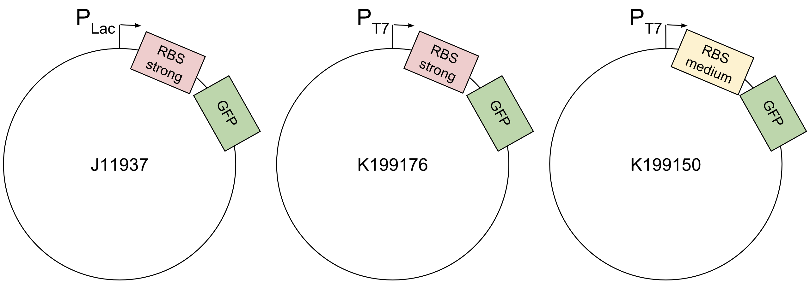

Supplementary Figure 2. Schematics of the plasmids employed as DNA template during in vitro protein expression assays. Parts J119137, K199176, and K199150 are in pSB1A2 plasmid backbones.

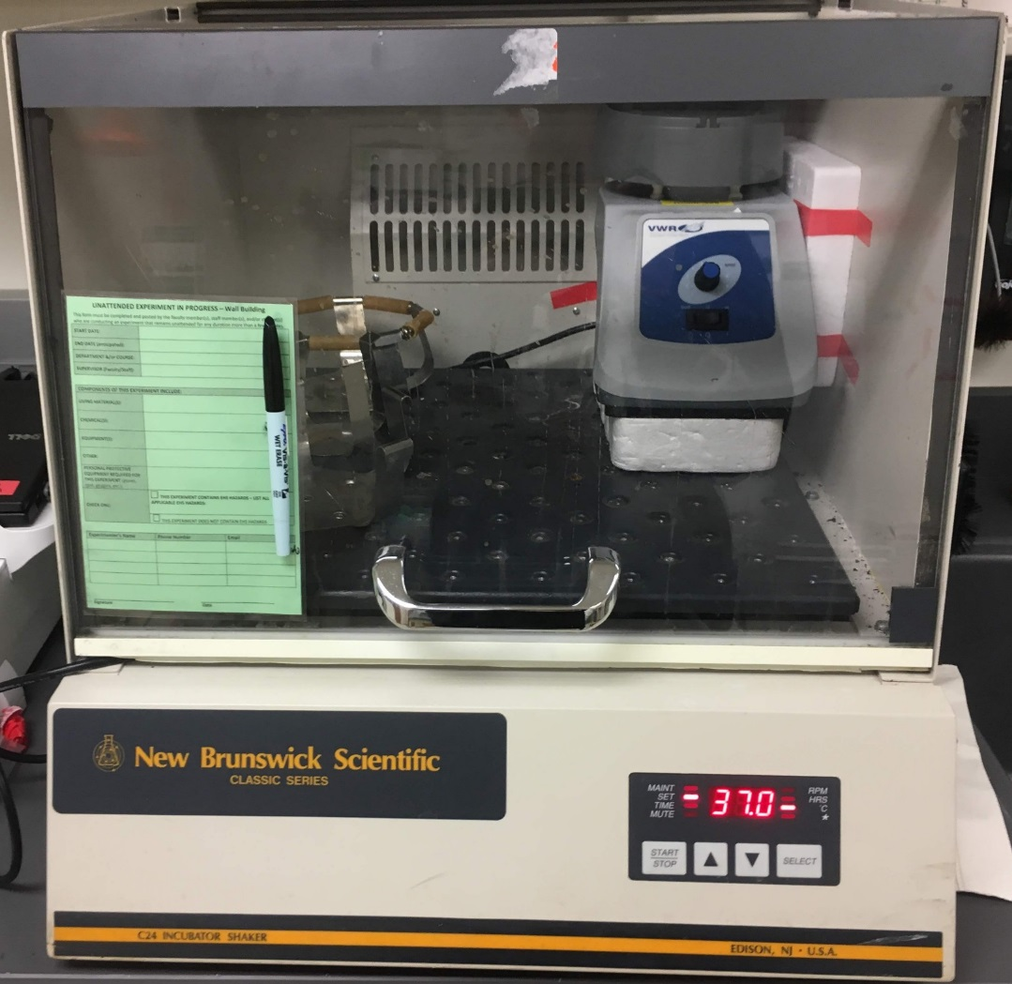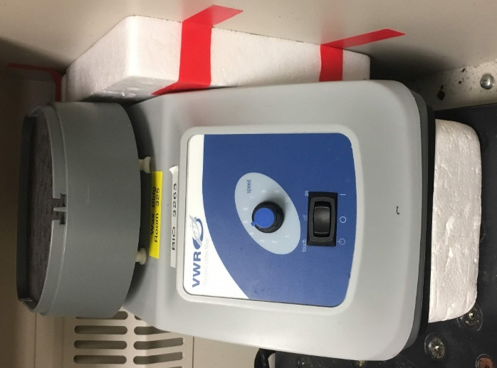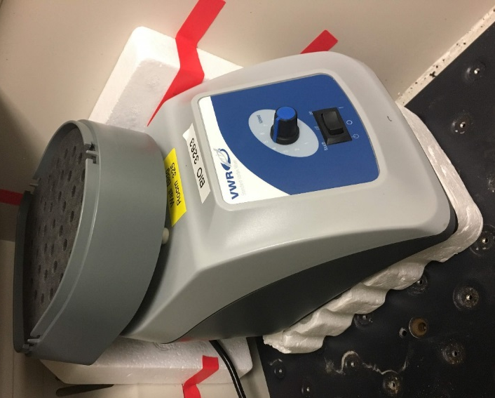

Supplementary Figure 3. VWR standard vortex mixer with an attached 500 µL microcentrifuge tube adapter in a benchtop incubator set to 37 ºC. Speed control knob is set to between 4 and 5, as employed when shaking CFPS reactions during incubation.
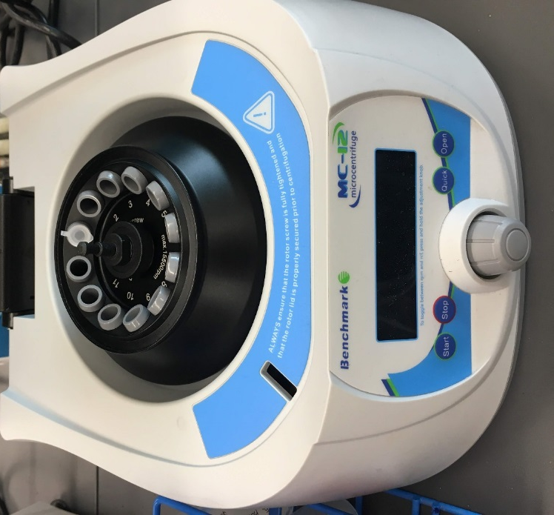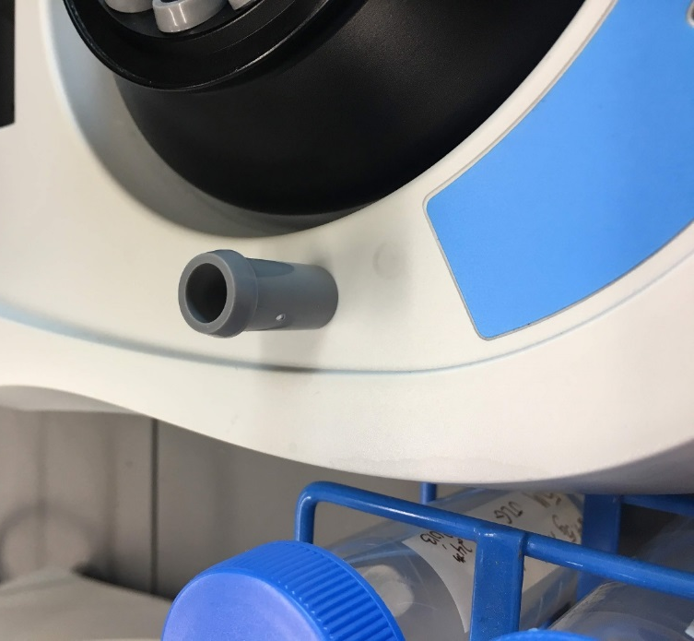

Supplementary Figure 4. Benchtop microcentrifuge used to centrifuge CFPS reactions prior to spectrophotometric analysis outfitted with 500 µL microcentrifuge tube adapters (left) and a close-up of one of the 500 µL microcentrifuge tube adapters (right).

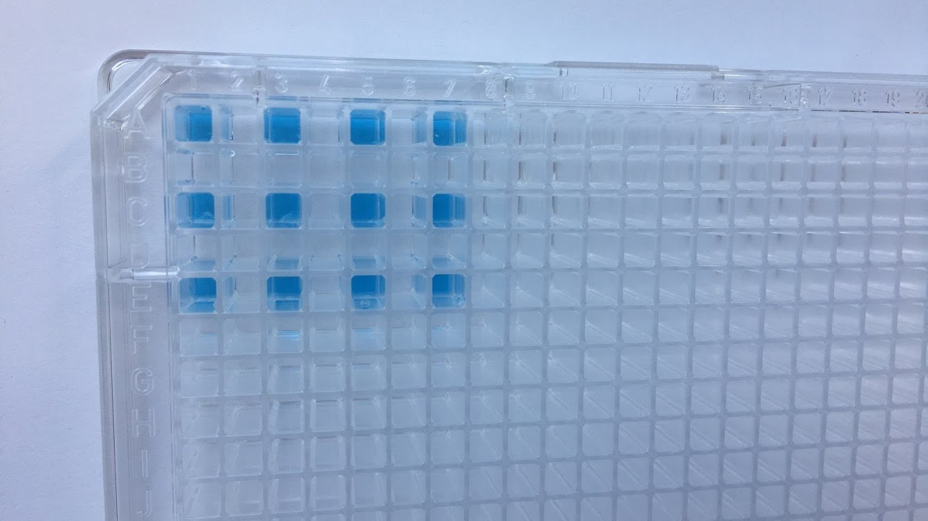

Supplementary Figure 5. A 384-well plate loaded with 50 µL bromocreosol green dyed-dH₂O in the arrangement employed for GFP endpoint spectrophotometry. Samples were pipetted into the 384-well plate such that each sample surrounded by empty wells to limit fluorescence “overflow” to adjacent wells.

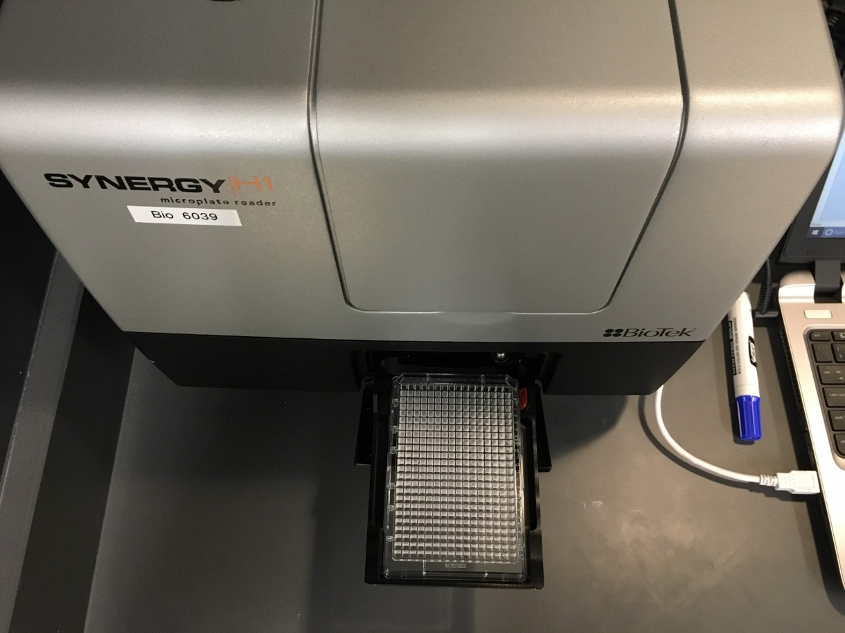

Supplementary Figure 6. An empty 384-well plate with no lid loaded into the bay of the spectrophotometer before quantification of GFP fluorescence.

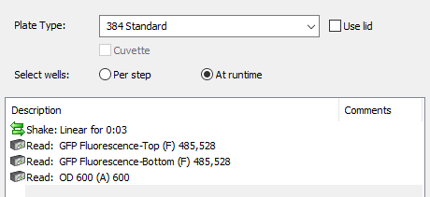

Supplementary Figure 7. A screenshot depicting the protocol used for endpoint GFP fluorescence quantification by spectrophotometry. Numbers following each read step represent absorbance or excitation and emission wavelengths, respectively.
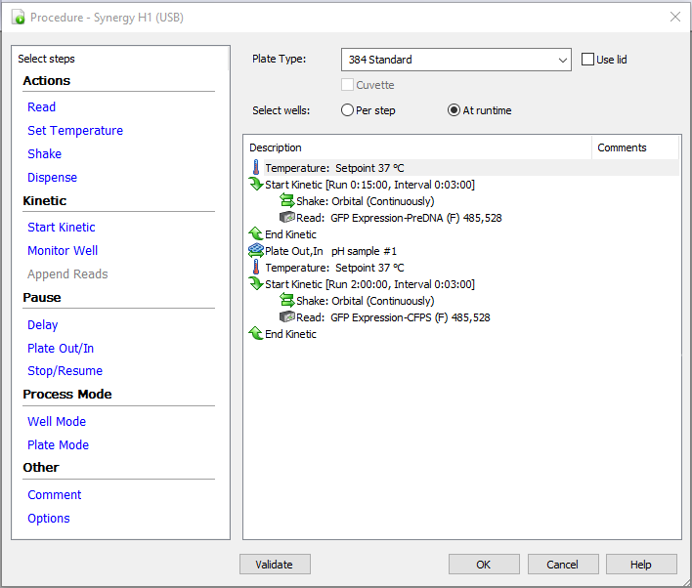

Supplementary Figure 8. A screenshot depicting the protocol used for kinetic read GFP fluorescence quantification by spectrophotometry for CFPS experiments including the pre-DNA incubation period. Numbers following each read step represent excitation and emission wavelengths, respectively.

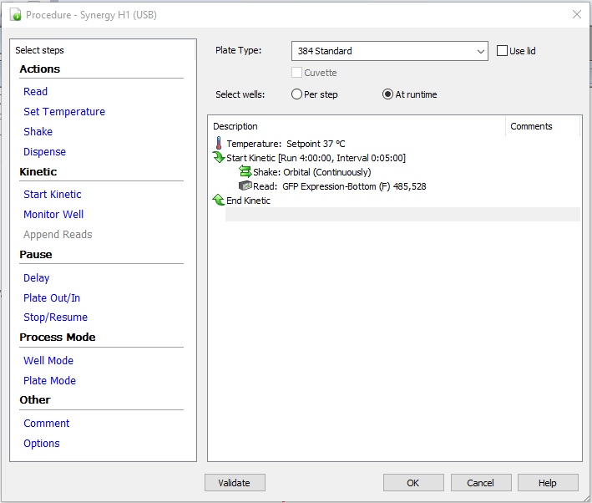

Supplementary Figure 9. A screenshot depicting the protocol used for kinetic read GFP fluorescence quantification by spectrophotometry for CFPS experiments omitting the pre-DNA incubation period. Numbers following each read step represent excitation and emission wavelengths, respectively.
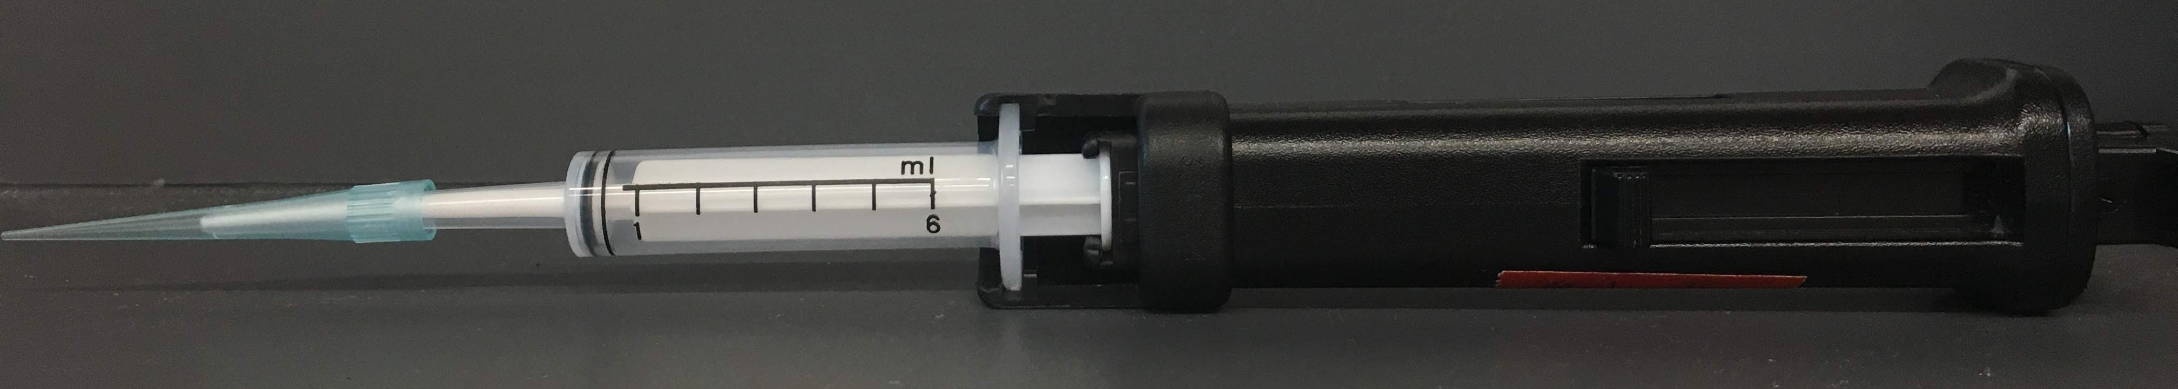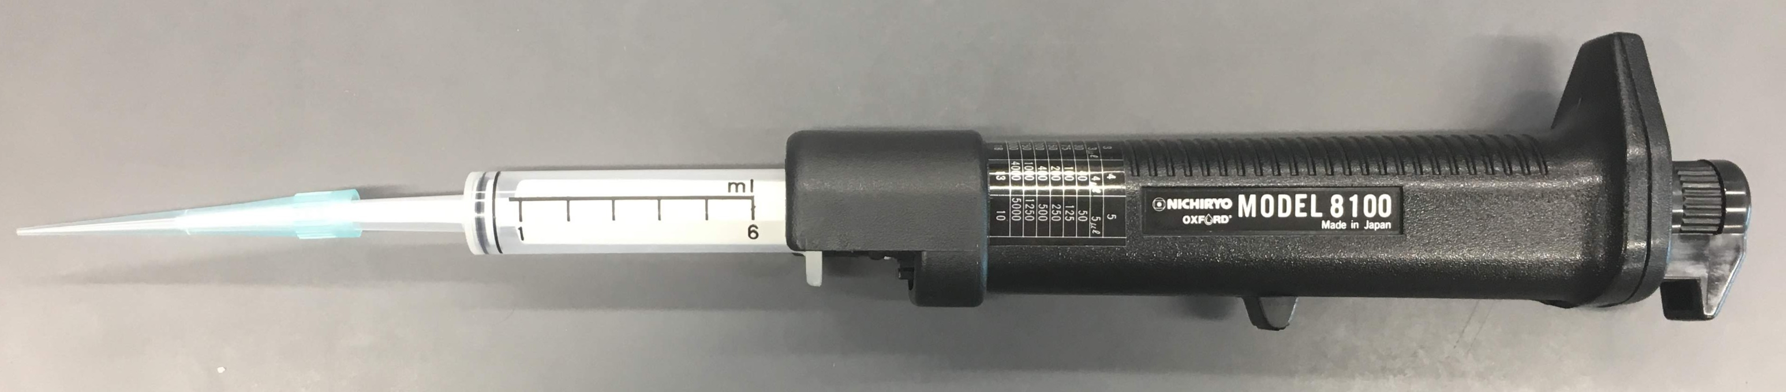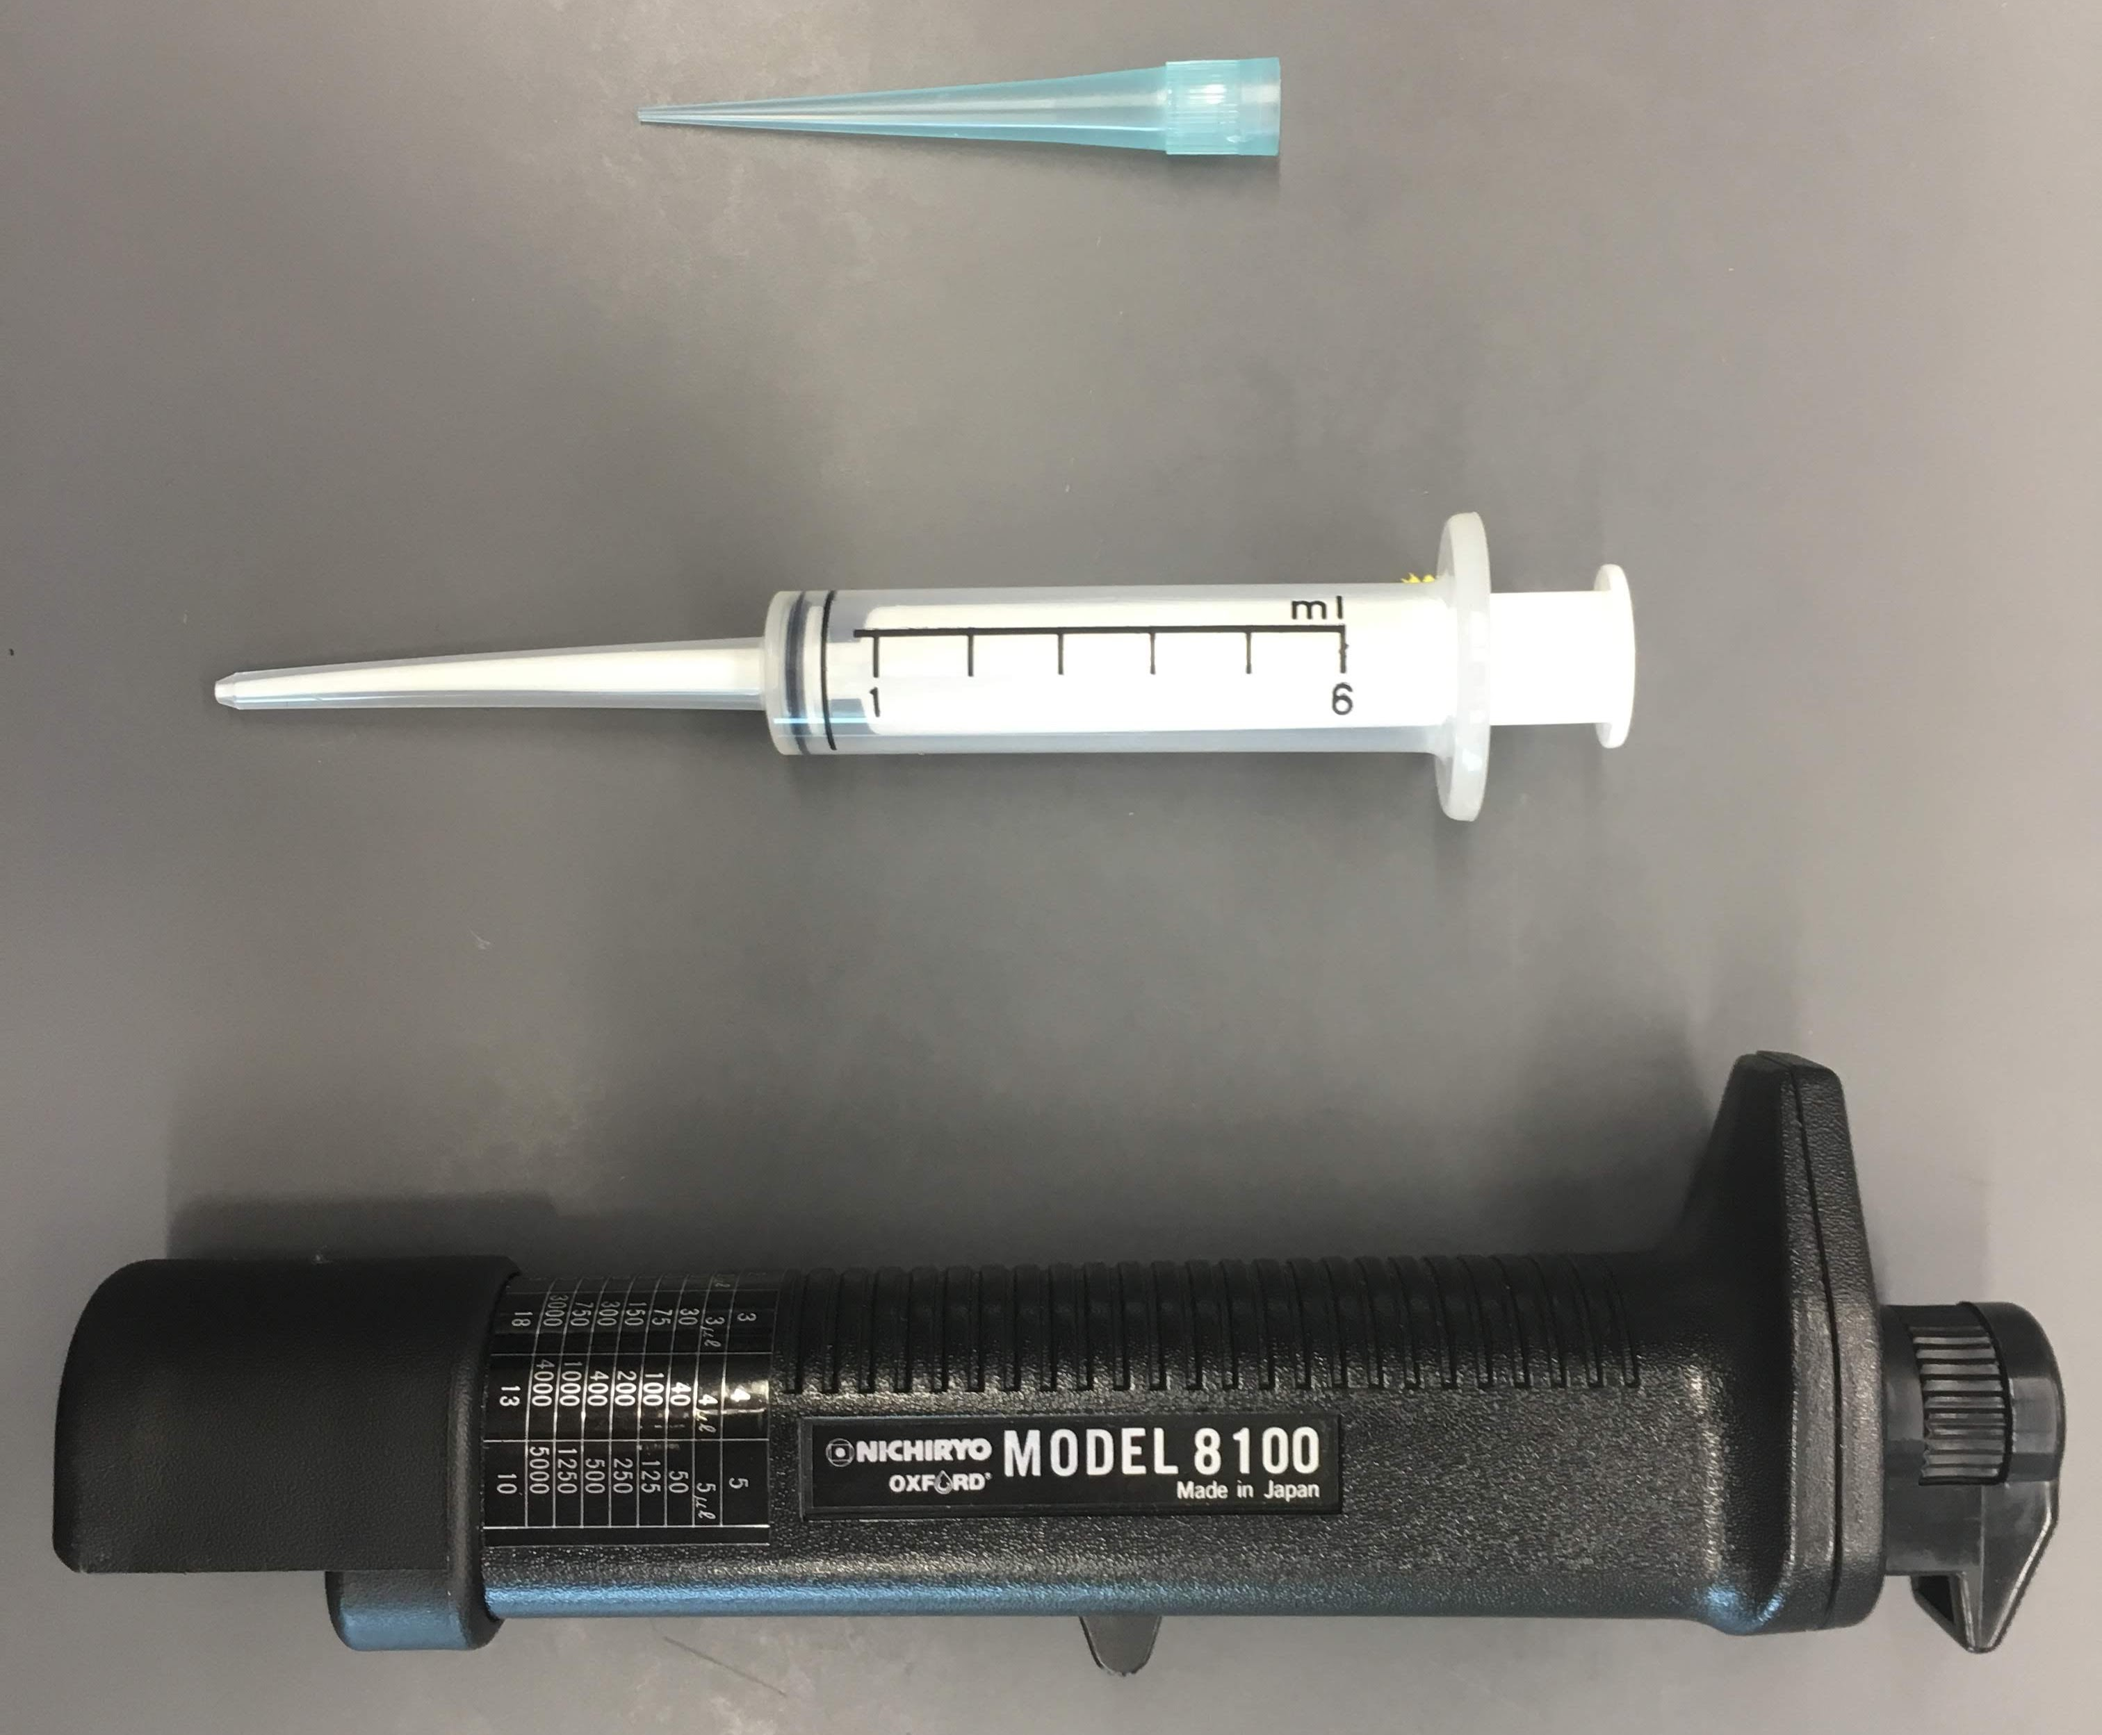

Supplementary Figure 10. The repipetter (Sigma # Z717428) used for aliquoting the lysate with an associated loading syringe (Sigma #Z717487) and a tip. We set the dial on the top of the repipetter to 2 and use the 6 mL loading syringes to fill the 1.5 mL Eppendorf tubes in which the lysate is stored with 200 µL lysate.

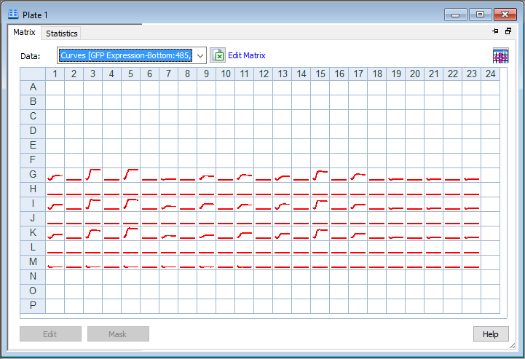
Supplementary Figure 11. The curves matrix automatically displayed on the plate reader interface during the incubation period. Clicking on one of these curves allows one to view the data in detail and to select additional wells to display.

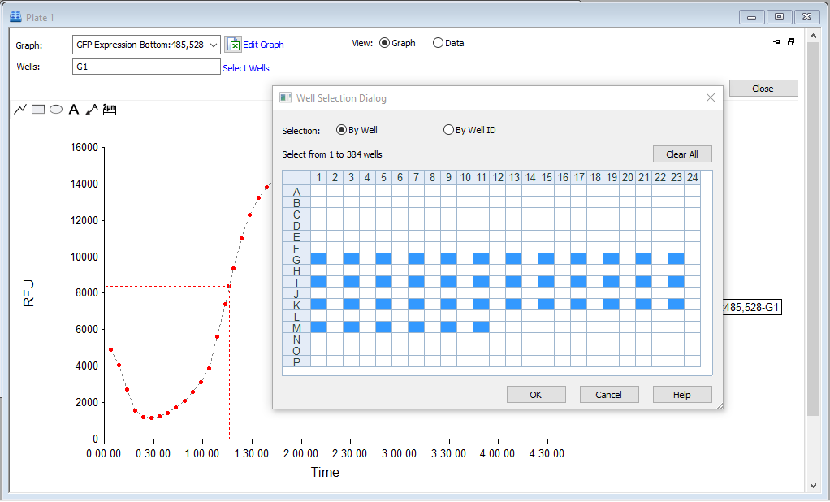
Supplementary Figure 12. The well selection window. We display only those wells which are filled with CFPS reactions. Wells are selected in the left-to-right order in which one would like them to appear in the columns of the Excel file to be exported.

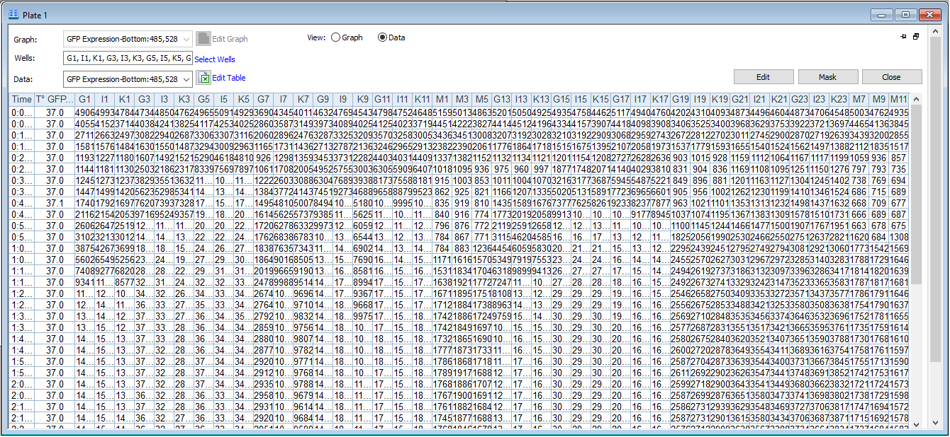
Supplementary Figure 13. The matrix of data generated in a CFPS kinetic read experiment. The exported Excel file will contain the same matrix. The time each read step began and the temperature during each read are recorded in addition to the GFP fluorescence of each reaction.

Appendix D

Protocol for CFPS in Microfluidic Droplets

Developed by Benjamin Bashaw, Missouri Western State University Department of Biology

This protocol describes how we used the OB1 MK3 Microfluidic Flow Control System from Elveflow to generate droplets for in vitro gene expression. Details about the system can be found here.

Consumables
- Droplet stabilization oil
- PEEK resistance tubing (90% of flow issues can be resolved by cutting a new length of tubing to replace old, given that the resistance tubing is the narrowest part of the system and most prone to blockages)
- Eppendorf 1.5 mL Safe-Lock tubes (need a special type of 1.5 mL tube for the reservoirs to create the airtight seal)

OB1 MK3 Setup Notes/Videos

Instructions for connecting the back side of the controller to an air pressure source, a computer, and a power source can be found here.

Instructions for connecting the back side of the controller to the flow sensor and the reservoirs can be found here.

Instructions for connecting the flow sensor to resistance tubing and the microfluidic chip can be found here.

- Resistance tubing (PEEK tubing) dimensions are 1/16 in. x .0025, and the length required varies based on the type of fluid flowing in it. We used 8 cm for water and 6 cm for oil (1% PFPE-PEG in HFE 7500) to achieve perfectly dimensioned (defined below) flow.
- Make sure the flow is perfectly dimensioned before connecting the tubes to the microfluidic chip - once connected, the flow may drop due to increased resistances of the microfluidic chip itself
- Perfectly dimensioned flow means that the resistance is just the correct amount so that the pressure range (0 - 2000 mbar) covers the full flow range (0 - 80 uL/min) in a linear relationship. When the pressure is set to 0, there is no flow. When the pressure is set to 1000 mbar, the flow should be around 40 uL/min, and when it is set to 2000 mbar, the flow should be around 80 uL/min, etc.
- You can test the resistance prior to connecting it to the microfluidic chip by running the resistance tuning module in the software, which will incrementally increase the pressure. The flow rate response will inform you that the resistance is too high, too low, or perfectly dimensioned.
- More viscous liquids require less resistance from a shorter length of resistance tubing.
- Insert the steel post connectors (the procedure for fabrication of steel posts is described below) into the semi-translucent tubing by gripping the steel post firmly with pliers and pushing/wiggling it about ⅓ to ½ way into the tubing.
- To insert steel posts into the microfluidic chip, put a small droplet of isopropanol on the opening of the microfluidic chip, grip the steel post firmly with a pair of pliers, and push it straight down into the hole.
- Keep in mind that PDMS is a gel, so be careful during and after inserting the steel posts.

An explanation of the microfluidic chip structure and how it produces droplets using oil and dispersive liquid here.

Instructions on installing and instruction about adding sensors and devices are found here.

Instructions on turning on the Elveflow machine are here.

Droplet Production Procedure

A useful video on droplet production is found here.

- Boot up the ESI interface and press the play button to open the software.
- Turn both channels off (click power button on top of each channel on computer).
- Press the silver button on the front of the black box to turn it on.
- Make sure oil and water are in the correct reservoirs.
- Turn on the main air pressure and set it to about 18 psi.
- Flip the air switch lever to ON.
- Set the pressure of the continuous (oil) channel to 100 - 2000 mbar and click the power button to flood system. You should see the oil coming down through the side channels in the microfluidic chip and flowing both up towards the oil/water inlet and down towards the outlet through the T junction.
- Once the inside of the PDMS chip has been saturated with oil, turn the oil channel off.
- Set the water and oil channels to 100 mbar. First turn on the water channel, then turn on the oil channel.
- It should take no more than 15 - 30 seconds to begin producing droplets.
- Vary the pressure based on the desired size of droplets.
- Position the end of the outlet tube close to the bottom of a collection tube. We used a 1.5 ml tube.
- After several minutes of continuous droplet production, you should begin to see the formation of an opaque white layer in the tube - this is the emulsion of aqueous droplets in oil.

Information on the procedure to shut down droplet production is found here.

At the conclusion of the experiments with water and oil, we recommend leaving the machine as is - however, if you are working with other liquids, we would recommend you swap the dispersive reservoir for water and produce droplets using that for several minutes to flush out CFPS mixture or other viscous liquids.

Droplet Visualization
- To visualize the droplets, you will need a compound microscope.
- Use a micropipette to transfer about 10 microliters from the water/oil interface onto a glass slide. Take about half of the volume from the opaque white layer and half from the clear liquid below (you can play with this ratio to vary the density of the droplets you see under the microscope). Place a cover slip on top (we suggest doing this with the slide already under the microscope and focused so that there is minimal time between pipetting and visualizing).
- Use a microscope camera to take images.
- The heat from the light and exposure to air around the edges of the cover slip render the droplets susceptible to evaporation and instability, so work quickly.
- For experiments that require imaging droplets over a long period of time, nail polish may be used to seal the coverslip to the glass slide for minimal air exposure.

Steel Post Connector Fabrication

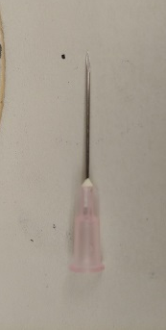
- Uncap and cut a 20 gauge needle at the base of the opening towards the pointed end with wire cutters (the end of the needle will become pinched, do not worry we describe how to fix this below).

- Dispose of the needle tip in a safe manner.
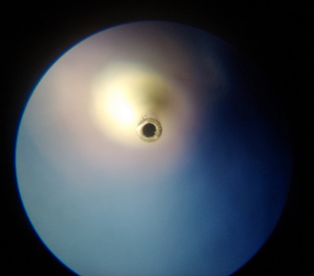
- Sand down the cut end of the needle with low grit sandpaper until a hole is visible.
- Sand some more with medium grit sandpaper until the hole is more circular and easily visible.
- Sand a little more with high grit sandpaper and observe under a dissecting microscope to make sure no burrs are visible.
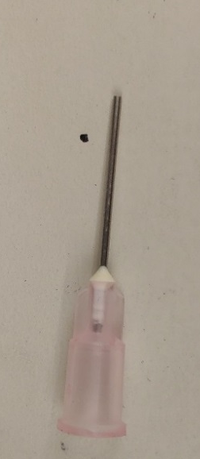

- Use a 24 gauge needle to clean out debris from the inside of the cut 20 gauge needle.
- Recheck the needle under a dissecting scope after sanding and cleaning as needed until no burrs/debris are visible.
- Cut the needle just after the white area near the base of the metal sheath and repeat steps 3-7 with the new cut end.
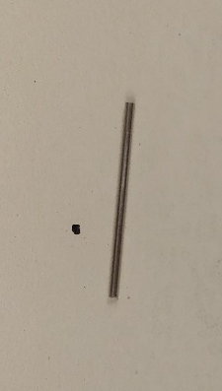

- You now have a finished, homemade steel post for attaching microfluidic tubing into PDMS microchips.

CFPS in Droplets

- Design the Master Mix
Open “CFPS Reaction Mixture Protocol Excel sheet and enter the amount of DNA template in ng/μl, total reactions in experiment and total amount of negative controls without DNA. The DNA concentration needs to at least be 50 ng/μL. The protocol requires a concentration of 50 ng/uL.

The spread sheet will give you the amount of Master Mix to make, with the values to use of each reagent in the mixture. CAUTION: do not add the DNA directly to the Master Mix, otherwise it is impossible to create a negative control.

- Preheat and Set up the Plate Reader
Turn on the BioTek Synergy H1 multimode microplate reader.
Wait for the plate reader to “warm-up” (it will make a series of noises and retract and extend its plate holder; Figure 6).
Open the plate reader/fluorometer program (Gen5.exe).
Set up the experiment by choosing the wavelengths and time between readings (if you are doing a “kinetic” experiment) (e.g. wavelengths for GFP excitation and emission are 485 nanometers (nM) and 528 nM respectively).
- It is important to make sure that there is no “shake” step in the protocol as it may affect the droplet experimentation readings.
- If you are doing a kinetic experiment, double-check the total time of the experiment as well as the length of time between reads.
Click on the small icon that looks like the fluorometer and click the pre-heating tab. Next, check the on box next to the requested temperature (37°C).
- CFPS
PLEASE REMEMBER TO MAINTAIN AN ASEPTIC ENVIRONMENT THROUGHOUT THE CREATION OF THE “MASTER MIX”
Add the specified amounts of the components of the CFPS according to the Excel spreadsheet.
Remember to vortex all components that have been in either the freezer or deep-freeze before adding to the master mix.
- Negative Control Droplet Generation
It is important to generate negative control droplets first to reduce the potential of carry-over from the experimental run.
To generate negative control droplets, aliquot 10 uL of Nuclease-free water and 40 uL of the master mix for each expected well into the dispersive reservoir of the microfluidic set-up.
Vortex the dispersive reservoir for ~5 seconds.
Add an equal amount of Droplet Stabilization Oil to the continuous reservoir (do not worry too much about waste, extra oil can be recycled and used in future experiments).
Open the Elveflow Software Interface (ESI) and click the “play” button next to the name of the pressure controller.
Click the “Stop all” button in the top right of the window.
Set both the dispersive and continuous channels to 600 mbar and click the power button.
Run both of the channels until you see no more fluid in the dispersive channel.
- Add Droplet Stabilization Oil as needed
  - Remember to click “Stop all” before unscrewing the reservoir cap
Finally, click “stop all.”
- Experimental Droplet Generation
REMEMBER TO PROPERLY CLEAN AND MAINTAIN THE FLOW SENSOR AND PDMS CHIP BY CLEANING THEM AFTER EACH EXPERIMENT
Aliquot 10 uL of DNA per reaction (reaction = 1 well in normal CFPS) and 10 uL nuclease-free water per reaction into the dispersive reservoir of the microfluidic set-up. Then aliquot 30 uL of the master mix per reaction into the dispersive reservoir of the microfluidic set-up.
-This will create a 75% dilute CFPS reaction mixture and will help with droplet generation by reducing the potential of clogging in the PDMS chip.
- If the DNA concentration is not 50 ng/uL, aliquot the expected amount of DNA and enough nuclease-free water to bring their total volume to 20 uL per reaction.
Vortex the dispersive reservoir for ~5 seconds.
Once you have filled the dispersive reservoir with the CFPS reaction mixture, add an equal amount of Droplet Stabilization Oil to the continuous reservoir.
Set both the dispersive and continuous channels to 600 mbar and click the power button in the ESI.
Run both of the channels until you see no more fluid in the dispersive channel.
- Add Droplet Stabilization Oil as needed
  - Remember to click “Stop all” before unscrewing the reservoir cap.
Finally, click “stop all.”

- Fluorescence Reading
Aliquot the batch (not in droplet) CFPS mixtures into the assigned 384 well plate wells.
- Remember to have a positive batch control for the 75% dilute reaction mixture.
Aliquot 50 uL samples from the droplet layer into the assigned 384 well plate wells.
Click the green arrow at the top of the screen (next to the piece of paper with a magnifying glass, not the one next to the floppy disk), and select the wells that you would like to have read.
Click “Okay.”
A pop-up with the current temperature will appear, click “OK.”
The fluorometer will read the specified wavelengths as dictated by the protocol.

